Events Details
Event Name | Details | Social Media Post
Pitch Refinement Workshop for Healthcare startups  Date – July 2,2024  Speaker- Ananya Chand | One-day interactive Pitch Refinement Workshop for startups.The workshop focused on positioning businesses as fundable entities, and each founder received personalized 1:1 feedback on enhancing their pitch decks. | Linkedin- https://www.linkedin.com/feed/update/urn:li:ugcPost:7214182067192881152/?actorCompanyId=79996765  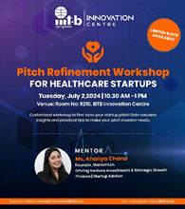
Defining Regulatory Frameworks for Your Healthcare Startup  Date- May 24,2024  Speaker- Sriram SL | Defining Regulatory Frameworks for Your Healthcare Startup" with Sriram SL a renowned medical strategist. This insightful event was designed to help navigate the complex regulatory landscape of the healthcare industry. | LinkedIn- https://www.linkedin.com/feed/update/urn:li:share:7199696643187777536/?actorCompanyId=79996765  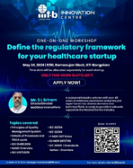
ABCs of Financial Planning with Ketoki Basu  Date- June 19,2024  Speaker- Ketoki Basu | Hands-on workshop on the ABCs of Financial Planning with Ketoki Basu. Participants engaged in a fully interactive session, gaining valuable insights into various levels and aspects of financial planning and pricing. | Linkedin- https://www.linkedin.com/feed/update/urn:li:share:7209414946684567554/?actorCompanyId=79996765  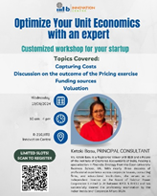
Go-To-Market Strategies for healthcare startups  Date- May 6,2024  Speaker- Ashim Roy | Offered invaluable insights into Go-To-Market (GTM) strategies. This session provided participants with personalized, one-on-one interactions with the mentor, ensuring tailored feedback and insightful inputs for their startups needs. | LinkedIn- https://www.linkedin.com/feed/update/urn:li:share:7193501124723695617/?actorCompanyId=79996765  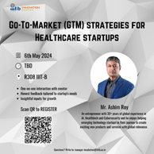
ABDM Opportunities for healthcare startups  Date- June 11,2024  Speaker- Kiran Anandampillai | Ayushman Bharat Digital Mission (ABDM) - Opportunities for Healthcare Startups". This talk by be led by Kiran Anandampillai CEO and Founder of iDrishti, and Technology Advisor at the National Health Authority. As a key contributor to the National Digital Health Mission and Ayushman Bharat, Kiran brings invaluable insights for healthcare innovators. | LinkedIn- https://www.linkedin.com/feed/update/urn:li:share:7205902390682656768/?actorCompanyId=79996765  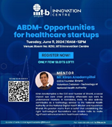
Demo Day  Date – July 12  Jury Panel- Sidharth(Pedal Start),Sathish(in44capital),Nitin Mittal,Ajay Shankar,Anirudh(javaCapital),Hari nandakumar,Manvi(Nasscom) | Demo Day provided startups with an opportunity to pitch to investors from across the industry who participated in the acceleration program. Each startup had a total of 10 minutes, with 7 minutes for their presentation and 3 minutes for pitching. The participating startups included Painzio, Zeuron.ai, VNIR Biotechnologies, Tinyprism Labs, Vajra Software Solutions, and Trawello Healthcare. | Linkedin - https://www.linkedin.com/feed/update/urn:li:ugcPost:7217456610376392705/?actorCompanyId=79996765  